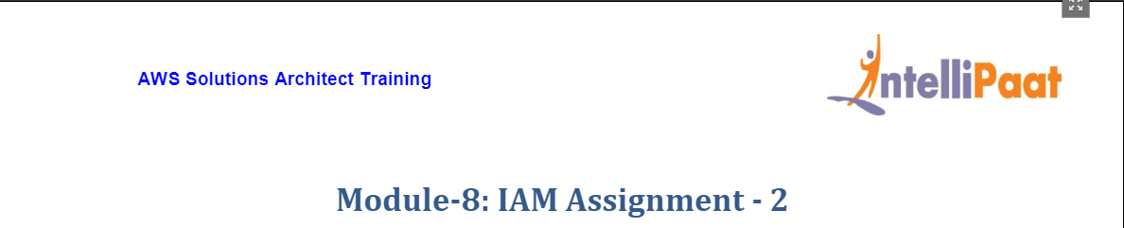

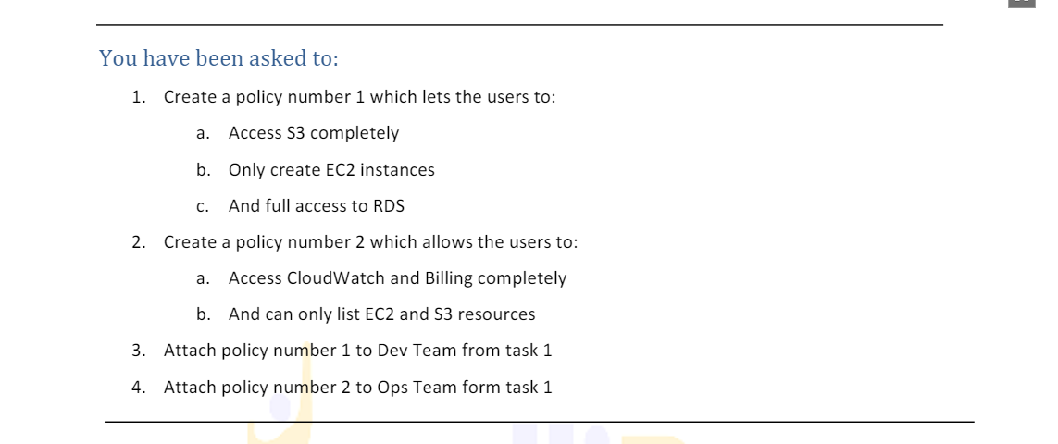

1. From IAM home we select Policies on the Left menu as shown below. Then click on Create Policy on the right.

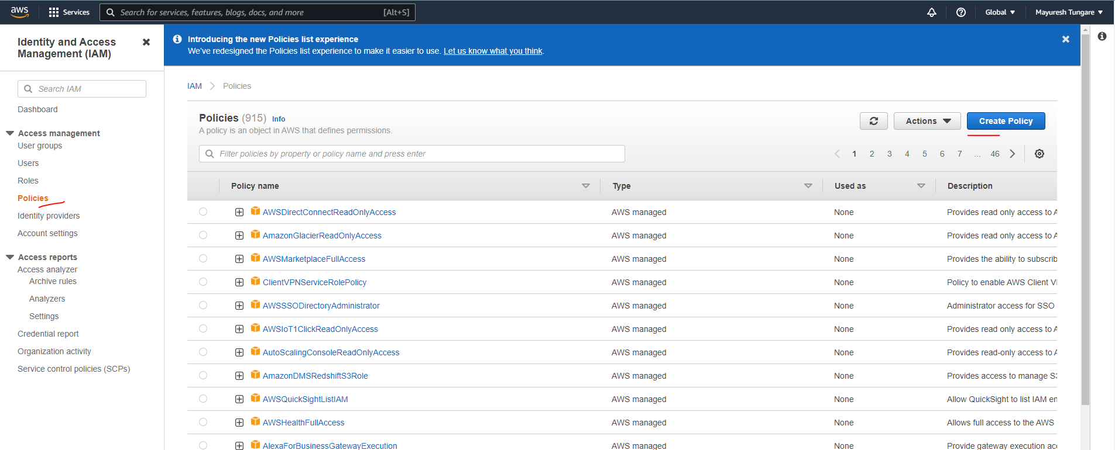

1. Create policy1 which gives full access to S3 and RDS, but only access to create (start) EC2 instances. Use JSON code as shown below:

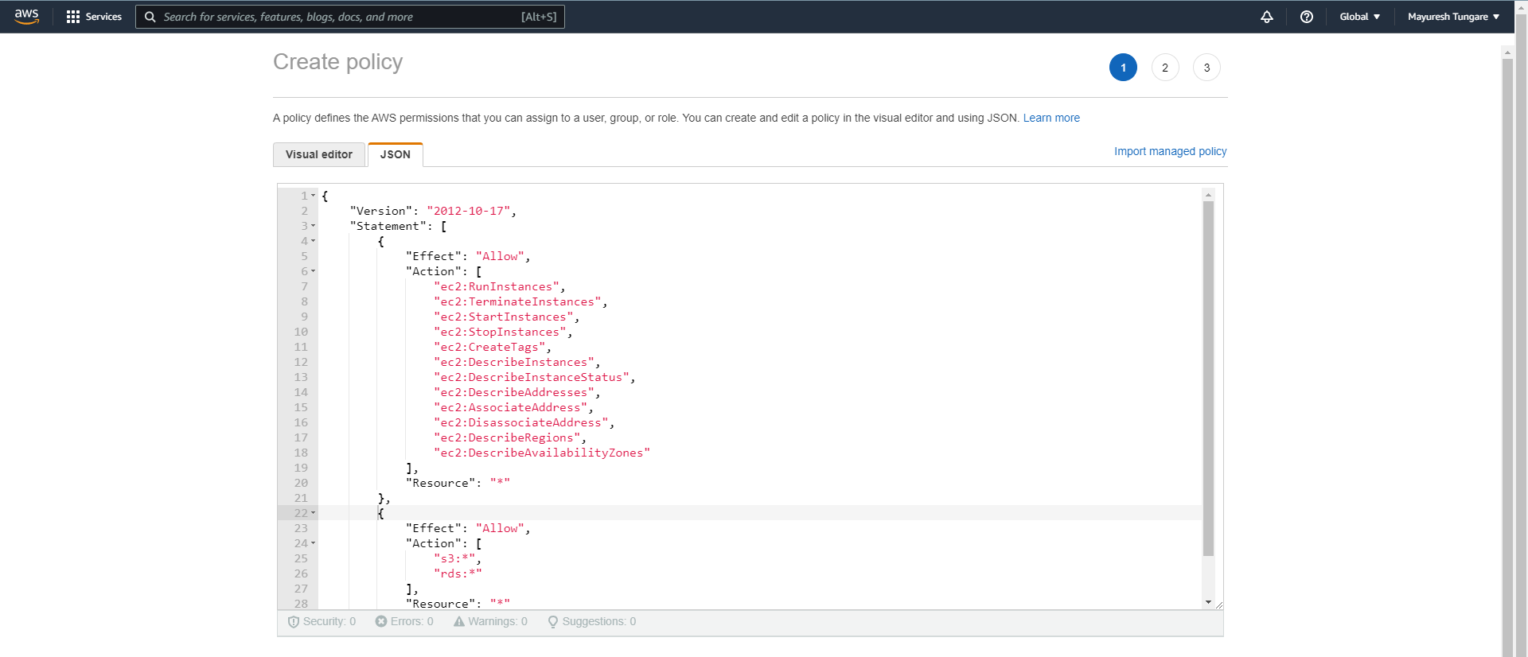

1. Now, create policy2 which gives full access to CloudWatch and Billing, but only access to list for EC2 and S3 as below:

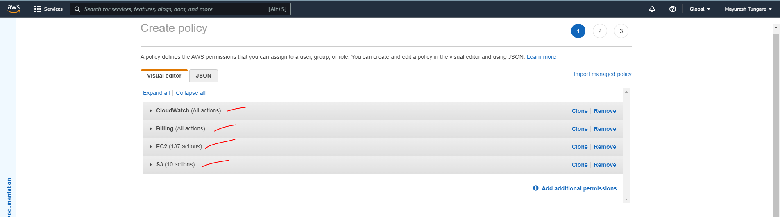

1. You can see now both the policies have been created. Refer snapshot below:

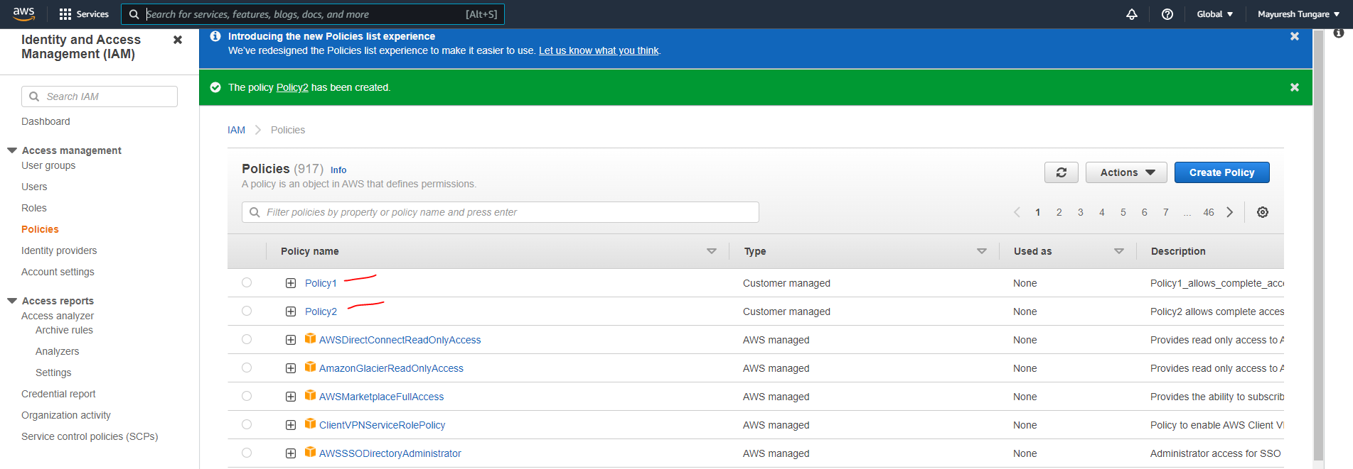

1. We now attach Policy1 to Dev Team

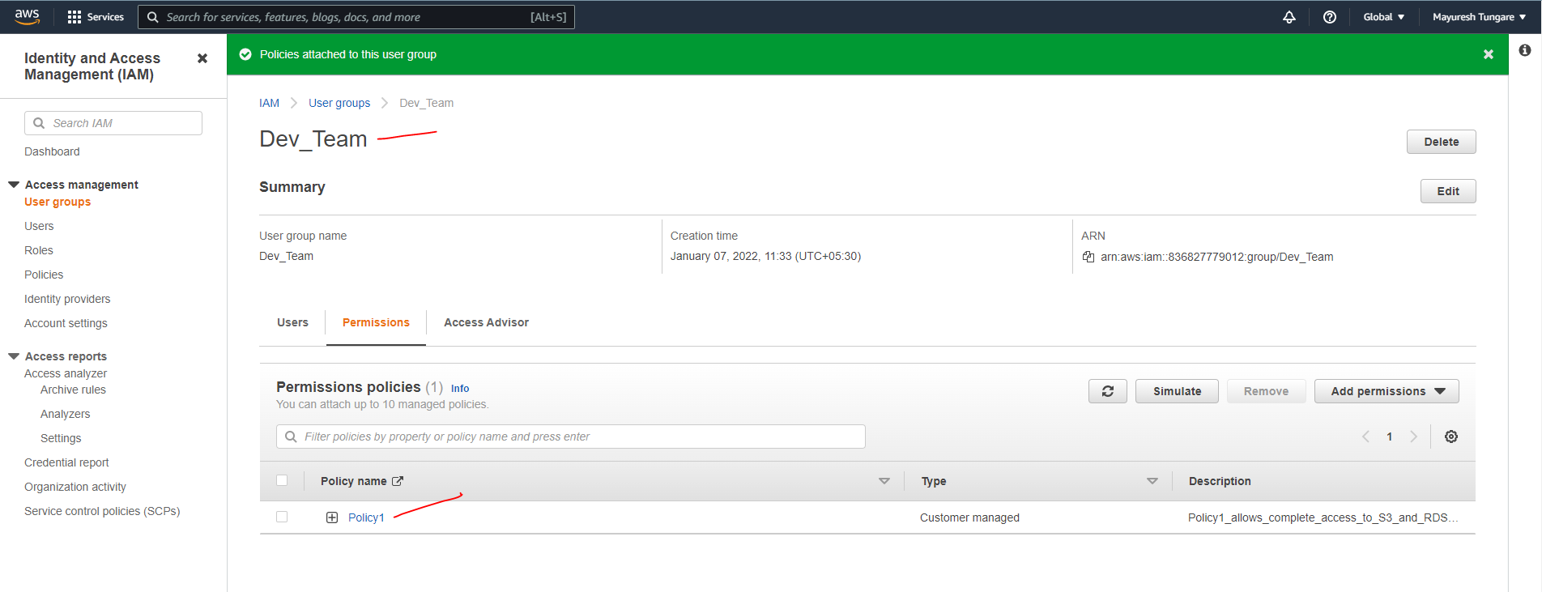

1. We now attach Policy2 to Ops Team

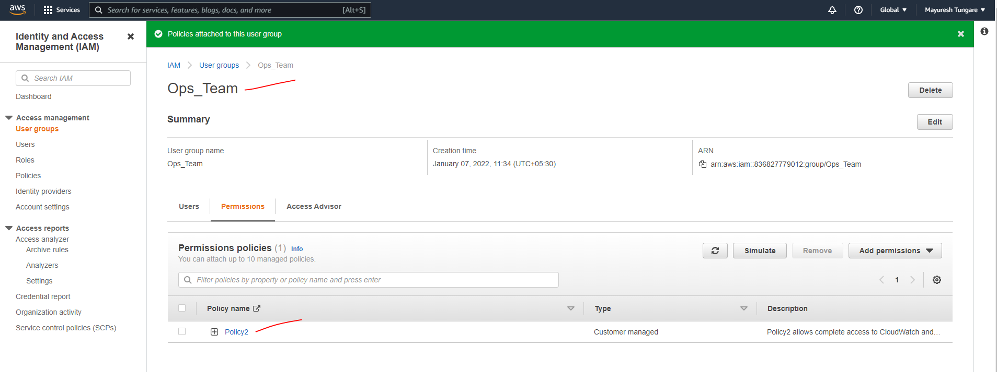

1. Thus, this assignment is now complete.